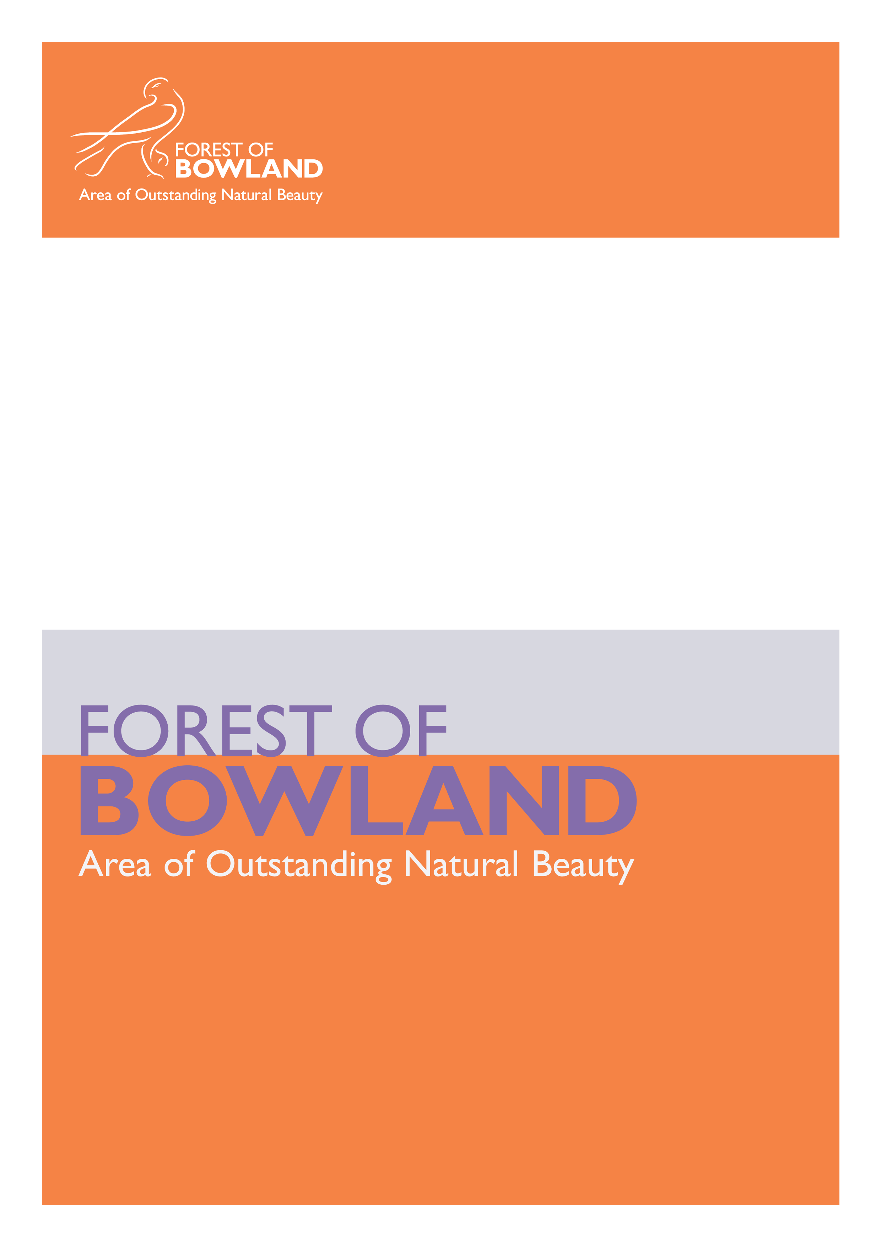
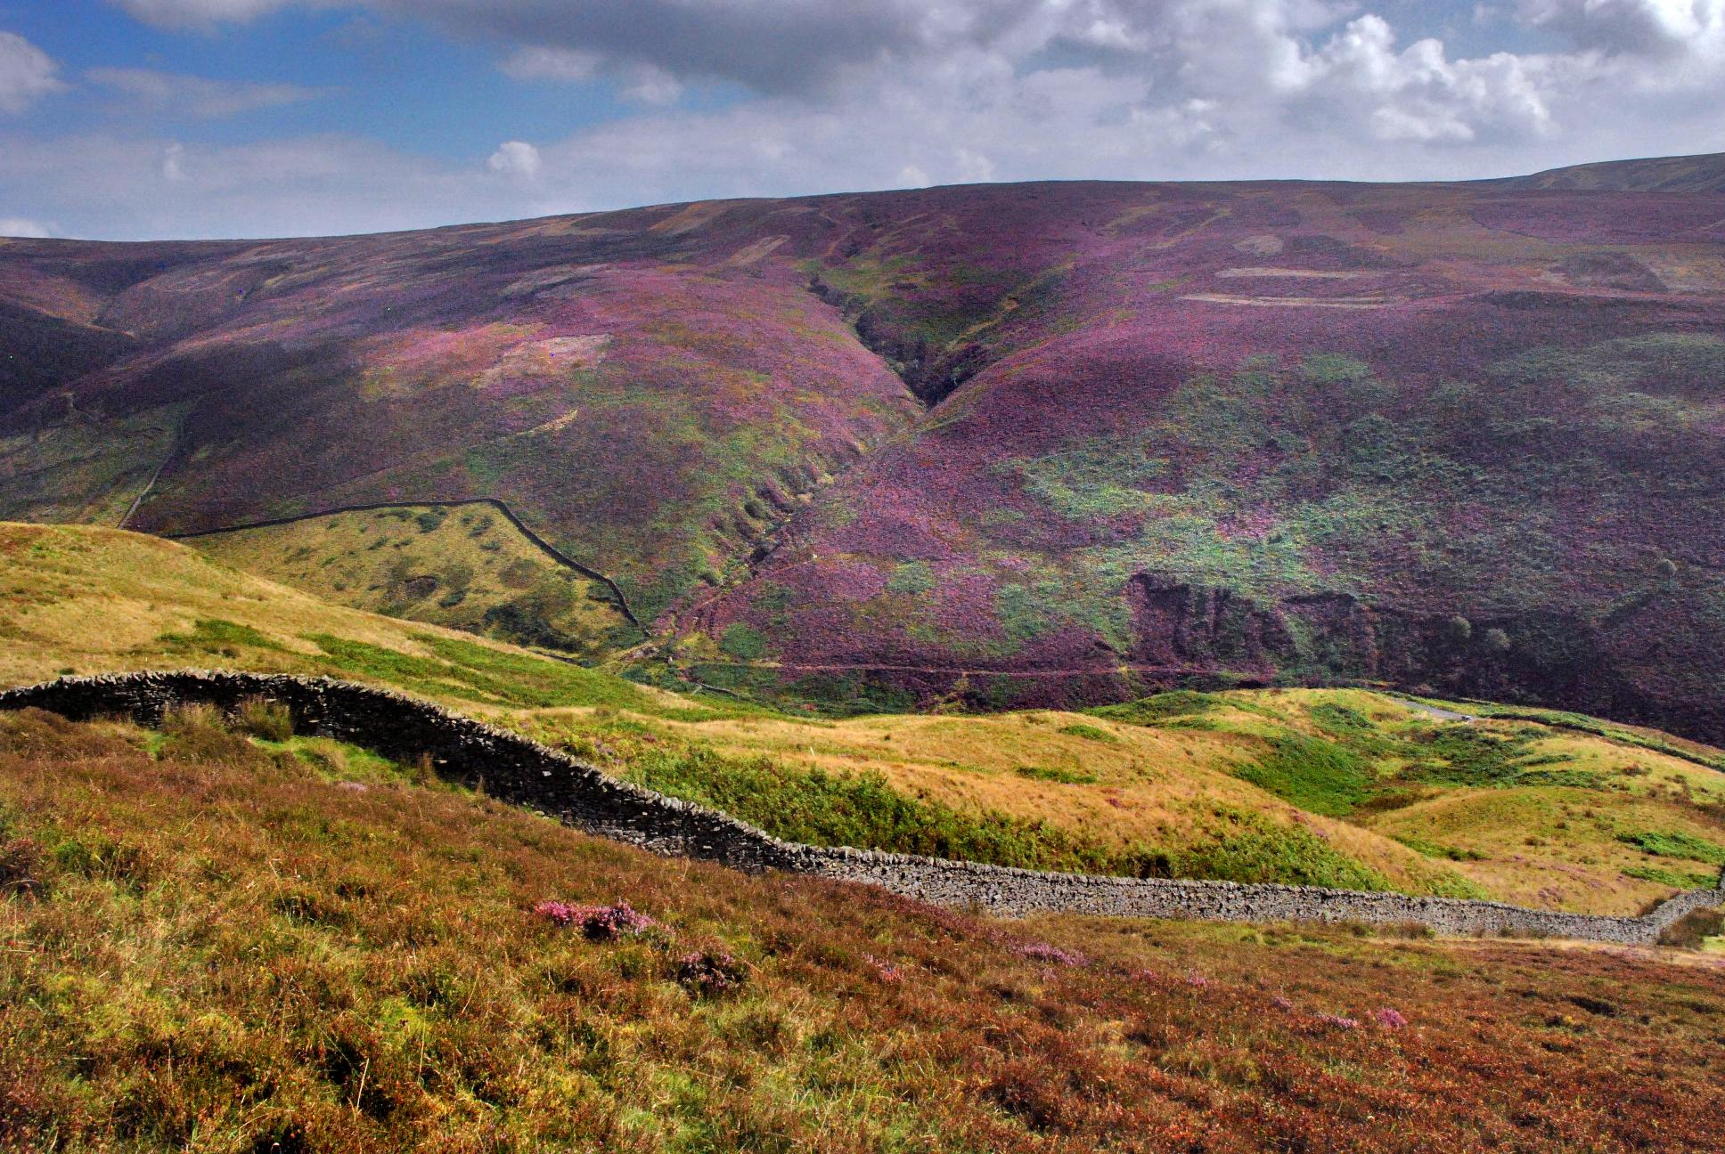Image goes here
Crop to 19cm wide by 9.36cm deep
Click format picture then under layout click advanced and place 1cm to the right of page and 5.65cm below page.
DELETE THIS BOX

AONB Report to JAC: October 2011

An outstanding landscape of natural and cultural heritage
Authors Name Authors Title
Date
Authors Name Authors Title
Date

Nature Improvement Area
The Nature Improvement Areas (NIAs) Programme with funding of £7.5 million has been established by Defra as announced in the Natural Environment White Paper (2011). Nature Improvement Areas are large, discrete areas that will deliver a step change in nature conservation, restoring and creating wildlife habitats, connecting local sites and joining up local action.
We have recently established a working group to develop and deliver a bid to the NIA Programme on behalf of the Forest of Bowland AONB. Focussing on those habitats identified as being most vulnerable to climate change, through our study earlier this year, we have identified a potential nature improvement area covering 300 km2 of the AONB. The aim will be to ensure the best management of important sites (SSSIs and BHSs) and to enlarge, buffer and connect these by creating, enhancing and restoring other sites in between to create more resilient networks of habitats.
The NIA bid is for £655,000 of Defra monies, which will be matched 50:50 by contributions from the various partners in officer time, HLS grant and a small amount of AONB project funds: totalling £1.3m over the period April 2012-March 2015.
However, be aware that this national programme is likely to be very competitive, with only 20 applicants entering the second round of bids in November, and only 12 being awarded funds in February 2012 – so please keep your fingers crossed and we will let you know if we progress!

Electricity Undergrounding
Two proposed schemes in Bolton by Bowland and Hyles moor have been evaluated by Electricity North-west and at the present time, due to cost implications and recent investment on the lines, will not be considered for undergrounding.
A number of other proposals have now been submitted for lines in Gisburn Forest and Roeburndale with some additional schemes being proposed for Slaidburn, Tosside and the Craven section of the AONB.
The scheme on Waddington Fell has been so successful that you wouldn’t even know there had been an overhead line running over the fell as you drive over the fell road.

Traditional Boundaries: Diploma students build up their drystone walling skills
15 students on a Diploma course in land based & horticulture Skills at Garstang Academy spent four days stripping down and rebuilding 30 metres of drystone wall under the expert tuition of master craftsman Mike Rushton from Tamarack Outdoors Ltd. This is the second year that the Forest of Bowland AONB has supported the practical and field visit elements of this course based at Cobble Hey Farm & Gardens. The students also build up skills in fencing, hedgelaying, flagging and a range of horticultural skills, as well as spending time out in the field or on the fell with local farmers, gamekeepers and countryside staff.

Resilient and sustainable rural communities

Lancashire Green Tourism Project
The Lancashire Green Tourism Project is due to complete at the end of September 2011. Over the 3 years the businesses have achieved some excellent results - 55 businesses achieving Green Tourism Business Scheme accreditation since 2007, and many businesses improving their grading levels from Year 1 of the project to Year 3. During 2011, through their ongoing commitment, nine businesses progressed from bronze and silver awards to silver and gold awards. A further 10 businesses are currently awaiting grading which will bring the total to 65.
Other project achievements include:
- Two new visitor leaflets – Tea Shop guide and Gisburn Forest Mountain Bike Trails
- Development of car free itineraries for Lancashire - in partnership with the Lancashire & Blackpool Tourist Board.
- Two self catering providers were short-listed for Gold Star GTBS awards; they have been highlighted amongst the 40 top GTBS accredited businesses in the country.
- 12 best practice case studies have been produced for GTBS gold accredited businesses.
- 100 businesses have received one-to-one support and guidance, web support and GTBS advisory or grading visits and 82 individuals have attended work-based training related to sustainable tourism.
- Production of downloadable walking routes linking GTBS accredited businesses
- Wildlife blogging websites developed by Barrie Tyrer web consultancy working with the Lancashire Green Tourism project to highlight the wildlife hotspots of this beautiful area, and most importantly, to entice visitors to take a look for themselves www.bowlandwildlife.org.uk and www.lancashirewildlife.org.uk
- A final piece of work for the project will be an online green guide to the Forest of Bowland AONB and Lancashire – to encourage visitors to holiday in a wonderful, green destination.
Many thanks to the project funders Lancashire County Council (LCDL) and the Lancashire and Blackpool Tourist Board (LBTB); Barrie Tyrer web consultancy for his ongoing support to businesses in developing their online green marketing messages and all the businesses who have been involved.

Bowland Experience Ltd.
BEx continues to grow and now has 77 members, 40% of which whom have set up in the tourism business since 2006. The role of the company and its relationship with the AONB has been defined as to:
Manage and promote the BEx website as "business-to-business" support network
Organise training courses for BEx members (e.g. AONB 'Sense of Place' training)
Initiate business-led cluster projects to promote sustainable tourism in the AONB, and if producing visitor information to utilise the AONB branding guidelines/template
Co-ordinate periodic network meetings for members to share ideas and good practice
Encourage members (and others) to support BTEF fund raising.
The website www.bowlandexperience.com has been developed to reflect these roles whilst the AONB team's responsibility is recognised as to manage and promote the AONB-branded website and printed materials as the primary source of visitor information for the area.
The Bowland Experience 'Tramper for Hire' scheme has been launched with funding support from The Three Fishes "Visitor Pay-back" donations and an Awards for All grant. Seven new Tramper trails are being set up across the AONB. The company has provided training courses for members and others on Customer Care, Visitor Information, First Aid at Work and Sense of Place.
The company achieved Revenue of £14,434 and made a Trading Profit of £2,555 in the year to July 2011. This amount will be donated to BTEF.

Bowland Tourism Environment Fund
The fund has continued to raise donations from visitors and others. It had a total income of £7,665 in the year to July 2011. It has been recognised as a 'charitable company' by HMRC which means it is exempt from corporation tax.
By coincidence, recent grants have been related to children's causes – support for Scorton village Playground, a contribution towards the RSPB-delivered Schools Outreach project and a grant for Dunsop Village School to provide a Hay Meadow Theatre Workshop.
The Three Fishes donation (referred to in the BEx report) is managed by BTEF and will be set aside to support the Tramper project.
The Trustees have written to all the Parish Councils in the AONB to publicise the grant scheme and are waiting to receive applications. For more information, see www.bowlandtefund.org

Parish Lengsthmen Project
The County Council is in the process of starting to review the pilot scheme on Lengthsmen that has been running this year with regard to how the countywide scheme will be supported in the future.
The officers within the AONB will be continuing to support and guide the existing parishes with longstanding schemes through this period of transition to continue the beneficial local delivery that has been so well received by the local communities.
A wide range of project work continues to be delivered across a large section of the AONB through the existing schemes.

A strong connection between people and the landscape

Communications & Branding
Online developments continue which in turn are attracting increasing traffic to the website. There were 9,252 visits to the website in May 2011, which included 76% new visitors. A consistently high number visit the website for walking and cycling information and downloads, general information on villages and visitor attractions and increasingly to search for accommodation and events. Highlights for 2011 include the launch of the 'Beautiful Bowland' photo competition with excellent prizes donated by tourism businesses in the network, a new online leaflet wizard to encourage tourism businesses to work in partnership with the AONB team to produce branded visitor information and a Festival Bowland online events calendar generated in Google which can be integrated into partner as well as tourism business websites.
Other communication activity includes re-prints of Bowland by Bike and Gisburn Forest Bike Trails leaflets, production of a new Marvellous Meadows leaflet (thanks to Martin Charlesworth, Jon Hickling and Geoff Morries) and new Sense of Place interpretation boards.

Education Commission
For the last four years we have supported RSPB to deliver an education outreach programme to primary schools within the AONB, via SDF and AONB project funds. As all our schools (27 schools and over 1000 children) have now participated in this programme we have decided to take a new approach to our education work from 2011/12 and are commissioning a project to be delivered by an environmental education specialist on behalf of the AONB. The project is currently out to tender and a consultant will be appointed in late October, to work for us from November to the end of March 2012.
Our aim is to provide a growing resource of on-line educational resources for schools, using the landscape of the Forest of Bowland as an outdoor classroom and inspiration. The project will identify what, and how, teachers want to study in the environment, and in our initial year, we will also talk to farmers who have 'educational access' to identify how we could best assist them with learning resources for their farms. Using this information, the project will make available a number of existing resources from the AONB website, and from other educational projects, and will also create new resources. For more information and to read the project brief in full go to
http://www.forestofbowland.com/environmentaleducation

Festival Bowland 2011
The chance to watch Whimbrel as they stop off at Barnacre on their epic journey from Africa to Iceland; a late night, torch-light quest to spot the bats in Brungerley Park and the opportunity to uncover the mysteries of the shave-horse on a green woodworking taster day – Festival Bowland 2011 offered all this and more !
This year's programme included over 160 events designed to celebrate the birds, wildlife, landscape and culture of the Forest of Bowland AONB and was supported by a range of partners including Lancashire County Council, Wyre Borough Council, RSPB, Bowland Arts Festival, United Utilities, Natural England, the Wildlife Trusts of Lancashire, Manchester & North Merseyside and a range of local businesses, landowners and farmers.
2011 also saw the introduction of an incentivised evaluation postcard scheme. Designed to collect feedback from event participants, the postcard was available from early summer. The intention is to run the scheme again next year, with distribution earlier in the calendar in order to catch the bulk of events during spring. Event proposal forms for the 2012 programme are now available and should be completed and returned by 12 noon on Monday 21st November.
For further information contact Sandra Silk on 01200 448000 or email sandra.silk@lancashire.gov.uk
Don’t forget that this year's festival programme runs right through to December, so there is still chance to get involved and perhaps discover something new about Bowland!

Royal Visitor to Bowland
As part of Festival Bowland a Royal visitor engaged a small group at Sawley Abbey to explain why he left the abbey in a ruinous state. This event was the first time we have engaged a character actor to deliver an event and also the first time we have used one of our few scheduled ancient monuments in the AONB as a venue for an event. The format was well received and we are looking at how we can broaden this style of event for next year's programme.

Uncovering Bowland's Past
United Utilities, Slaidburn Archive and the Forest of Bowland AONB are working on an exciting new project to uncover a piece of Bowland's heritage – and getting valuable help from volunteers and members of the local community.
The project focuses on the site of the original St. James' Church, Stocks-in-Bowland, between the villages of Tosside and Slaidburn. Consecrated in 1852, the church was demolished during the construction of Stocks Reservoir in the 1920's and early 1930's and eventually rebuilt on its present site at Dalehead.
The site of the original church became part of School Lane car park on the edge of Gisburn Forest and recent plans to improve the layout of this popular car park also provided the opportunity to safeguard the footprint of this valued local building.
Following a successful launch of the project at Tosside Community Hall, which attracted over 50 people, work recently started on the ground under the professional eye of experts from Lancaster-based Oxford Archaeology North. Initial survey work allowed the outline of the building to be located and excavation of the foundations of the church has now begun. The ultimate aim of the project is to reinstate these foundations in order to provide a visible reminder of the community living at Dalehead before the construction of the reservoir.
Phase one of the project, which is being funded by United Utilities with additional funding from the AONB, will run through October, finishing early in November, with plans for a second phase in spring next year.
For further information contact Sandra Silk on 01200 448000 or email sandra.silk@lancashire.gov.uk

Tramping across Bowland and Beyond
On the west side of Bowland, the self-guided Tramper Trails linking rural tourism businesses who make up the Wyresdale Wheels partnership have become so popular that the demand for similar trails elsewhere in Bowland has grown. So much so that extra help is being provided through a consultant who will work with the Environmental Projects officers to develop seven more trails. Ribble Valley Inns (Bowland Experience Ltd member) through their dedication and support in raising monies through visitor payback for the Bowland Tourism Environment Fund are helping to finance this work.
In July, for the sixth successive year, Lancashire hosted the Disabled Ramblers for four days in Bowland and Arnside Silverdale AONBs and also provided the opportunity for local Lancashire residents to join the treks using one of the 11 Trampers loaned by Lancashire County Council, Wyre Borough Council, Wyresdale Wheels and Bowland Experience Ltd. More than 30 local Tramper users, plus friends and family, explored the delights that the area has to offer ranging from the limestone pavement, flower rich grassland and mosses of Silverdale through to the woodlands of Grizedale valley and wilder expanses of Caton Moor.
Footnote: A Tramper is a specially designed all-terrain electric buggy, which can be used off-road and on rough ground, mud and grasses. It enables people who have difficulty walking, who are less able, or who may be disabled to experience the countryside, woodlands and lakesides and to accompany friends and family when out walking.

Evaluating the Parish Lengthsman Scheme and Taking it Forward
Since the Parish Lengthsman Scheme was first piloted in 1997/8 this partnership way of working between the Forest of Bowland AONB, Lancashire County Council Countryside Services, local district councils and parish councils has continued to operate and evolve successfully both within and beyond Bowland. An evaluation of the Forest of Bowland AONB schemes was carried out in 2002 and several recommendations made at the time. Currently a new evaluation is being carried out focusing on the six schemes which operate in 18 parishes in North Lancashire. The Forest of Bowland AONB is also reviewing the way in which it will continue to support parish councils to fund and manage the existing Parish Lengthsman Schemes - (11 Parish Lengthsman schemes working with 26 parishes across the Forest of Bowland AONB).
At the same time Lancashire County Council is currently reviewing its involvement and support of Parish Lengthsmen schemes and carrying out pilot work on new ways of working with parishes on Public Rights of Way maintenance.

A dynamic and effective AONB partnership

National Association for AONBs (NAAONB) and Joint-working
Three members of the AONB Unit attended the NAAONB Annual Conference in Penryn, Cornwall during July 2011. The team were able to hear from, and visit, local AONBs (Cornwall, Isles of Scilly and Tamar Valley), learning about projects on sustainable tourism, local food growing, community rail developments and habitat restoration. The Conference programme included a video address from HRH Prince of Wales in which he displayed his knowledge of - and great enthusiasm and support for - the work AONBs do across England, Northern Ireland and Wales. The NAAONB also presented a new business plan at the Conference, which aims to give the Association a sustainable future in a period of increasing funding uncertainty - moving their funding model away from reliance on direct Defra grant. This will result in an increased membership fee of £1200 in 2012/13.
In addition, the AONB Unit has contributed to a range of consultation responses to government made by the NAAONB on rural economic development, renewable energy, ecosystem services and the National Planning Policy Framework.
Finally, Elliott Lorimer (Principal AONB Officer) has been in discussion with Lucy Barron (AONB Manager for Arnside and Silverdale AONB) about ways in which the AONB Units can work jointly (e.g. towards the development of an AONB Design Guide) and share resources, particularly given the future planned reductions in Defra funding for AONBs.

EUROPARC Charter Award
The Forest of Bowland was commended by the EUROPARC Charter award in 2010 - "The Committee felt that the Forest of Bowland is leading the way on implementing Charter part II, and promoting good practice in working with businesses."
As a measure of this recognition of 'best practice' in Bowland, members of the AONB team have been invited to speak at the following events during 2011:
Nature Tourism Conference, Riga, Latvia
Tourism Operators' Seminar, Olot, Spain
National Park Management Conference, Steenwijk, Netherlands
Sustainable Tourism Conference, Causeway Coast and Glens Heritage Trust, Ballymena, N.I.
EUROPARC Atlantic Isles Seminar, Oxford
Galloway Biosphere Reserve Conference, Dumfries & Galloway
In addition, two of our key GTBS businesses, Clough Bottom Farm and Ribby Hall, also spoke at, and represented the AONB at, the EUROPARC Charter Park Seminar in Serbia in June, and the EUROPARC Conference held in Germany in September.
The team has also been approached and/or visited for advice on how to implement the EUROPARC Charter by the Cotswolds AONB, Nidderdale AONB, Peak District National Park and Yorkshire Dales National Park and is represented on the EUROPARC's Sustainable Tourism Working Party.
For April 2012, the annual AONB conference will be extended to invite practitioners from other protected areas in the UK to attend a workshop on Sustainable Tourism and Bowland will host the EUROPARC Atlantic Isles Charter Network meeting.

Forest of Bowland AONB Annual Report 2010/11
The 2010/11 Annual Report for the Forest of Bowland AONB is now available on the AONB website and can be accessed by following this link http://www.forestofbowland.com/files/uploads/pdfs/annualreport1011.pdf
The Annual Report is a wonderful opportunity to highlight the range of projects carried out by partners, both on the ground and behind-the-scenes, and reflects the hard work which takes place throughout the year. It is a valuable means of informing a wider audience of our work, celebrating our achievements and encouraging people to get involved. Many thanks to everyone for their contributions this year and don't forget to start thinking about projects for next year's report!

